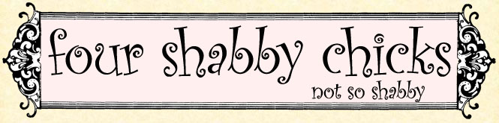
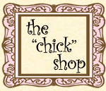

four shabby chicks
30 S. King Street
Leesburg, Virginia 20175
(703) 669-0380

S

Thursday, November 23, 2006

happy thanksgiving
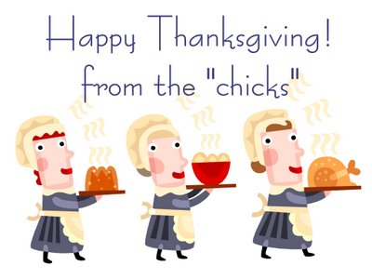
posted by one of the four shabby chicks on Thursday, November 23, 2006 0 "chicks" chirped in

Monday, November 20, 2006

towns & villages
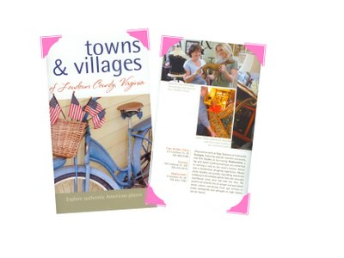Here we are featured in the latest Loudoun Convention & Visitors Association Guide titled "towns & villages of Loudoun County, Virginia -- Explore authentic American places." We are listed on page 4.
The guide offers visitors and insider's view of our communities and features Leesburg, Middleburg, Purcellville, Lovettsville, Hamilton, Round Hill and Hillsboro. Also features a great fold-out map of Loudoun.
The visitors center is located at:
222 Catoctin Circle, SE, Suite 100
Leesburg, Virginia 20175
703-771-2170
800-752-6118
www.VisitLoudoun.org
posted by one of the four shabby chicks on Monday, November 20, 2006 0 "chicks" chirped in

Thursday, November 16, 2006

home, at last
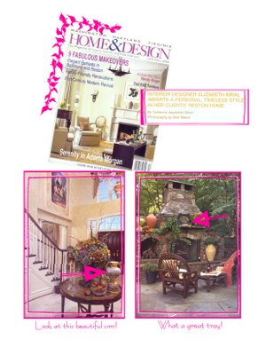One of our good customers, Elizabeth Krial, is an Interior Designer who was just featured in the Fall 2006 issue of "Washington Home & Design." On a recent shopping trip to the four shabby chicks she purchased several items -- a couple of them are shown above. The article "Home, At Last" is featured on pages 164-173.
Didn't she do a fabulous job!

