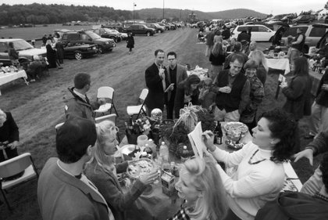
Tracy A Woodward/twp
DATE:10/19/2002 SLUG:ME/GOLD CREDIT:TRACY A WOODWARD/TWP NEGATIVE NUMBER:woodwardt 132686 The 65th Running of the International Gold Cup Races, Great Meadow, The Plains, VA. Fears of the sniper can't stop the fancy tailgaters and horse enthusiasts from their cherished steeplechase races at Great Meadow. Tailgaters enjoy the races, food, and a little light betting. This table is provided by Elizabeth and Mark Krial. The lady in white, in center holding program, is taking everyone's pick of winner, for the next race. She is Ann Reimers of Leesburg, VA. She is the sister of Elizabeth Krial. Their friends have joined them at the table.

